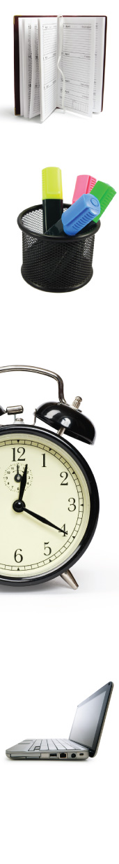 | Agenda  SCHOOL NAME PTO  Meeting Date:  Meeting Location:  1. Call to Order  2. Minutes: Review of minutes from mm/dd/yy meeting  3. Officers’ Reports  a. President’s Report  b. Vice President’s Report  c. Treasurer’s Report  4. Committee Reports  a. XX Committee  b. YY Committee  Note: The agenda serves two purposes: It’s a guide for conducting the meeting, and it’s an informational tool for prospective attendees. Include as much detail as possible on your agenda, so people will know what to expect at the meeting. And be sure to follow it.  c. ZZ Committee  5. Principal’s Report  6. Unfinished (old) Business  a. Topic  b. Topic  7. New Business  Note: If you have a guest speaker, it’s OK to insert the speaker at any point on your agenda to accommodate his schedule. You also may have the speaker make his presentation before or after the meeting.  a. Topic  b. Topic  8. Announcements  9. Adjournment

